

**Studying the past**

I Vocabulary

|  |  |
| --- | --- |
| Archaeology | :The study of old objects to learn about past human life |

|  |  |
| --- | --- |
| Artifact | :An object made or used by people in the past |

|  |  |
| --- | --- |
| Historian | A person who studies and writes about the past |

|  |  |
| --- | --- |
| Inscriptions | :Writings carved on stones or metals used in ancient times |

|  |  |
| --- | --- |
| Source | :Clues or evidence that help us understand historical events and life |

II KWL

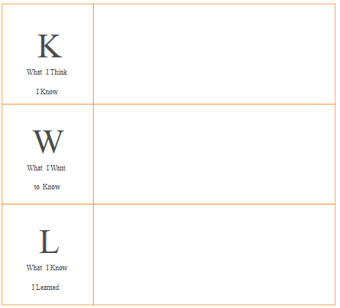

III Concept Map

IV. Answer the following.

**1.What are Monuments?**

Monuments are old buildings, structures, or statues built in the past to remember important people, events, or cultures. They help us learn about history and architecture of earlier times.

**2.write a short note on pre-history.**

Prehistory is the period of human history before writing was invented. Since there are no written records from this time, historians learn about prehistoric life through **tools, cave paintings, bones, and other objects** left behind.

Prehistory helps us understand how humans evolved, hunted, made fire, and began farming.

**3.Pottery is one of the most common finds on an excavation site. Why?**

Pottery is commonly found at excavation sites for the following reasons:

* **Durability**: Pottery is made from baked clay, which does not decay easily, so it lasts for thousands of years underground.
* **Daily Use**: Ancient people used pottery for everyday activities like cooking, storing food, and carrying water, so it was widely used.
* **Cultural Clues**: The shape, design, and decoration of pottery help archaeologists learn about the art, culture, and lifestyle of past civilizations.
* **Dating History**: Pottery helps in dating the layers of excavation, as styles and techniques changed over time and differ by period.

**4. What are inscriptions ? How do they help us?**

**Inscriptions** are writings engraved on hard surfaces such as **stones, pillars, metal plates, and walls**. They were often used in ancient times to record important events, royal orders, victories, donations, or achievements of kings.

### **How Inscriptions Help Us:**

1. **Provide Historical Information**: Inscriptions tell us about the rulers, their achievements, and important events of the time.
2. **Reveal Language and Script**: They help us understand the languages, scripts, and methods of communication used in ancient times.
3. **Show Social and Cultural Life**: Some inscriptions describe religious practices, festivals, and customs of people in the past.
4. **Help in Dating Events**: Inscriptions often include dates or reference to rulers, which help historians fix the time period of events.
5. **Support Archaeological Findings**: Inscriptions confirm information obtained from other sources like coins, pottery, and monuments.

## **5.Create a History Detective journal –**

## **Students bring a photo or object from home**

## **and write a short paragraph about its**

## **history.(Individual choice)**

## **(Sample answer)**

## **History Detective Journal**

**Name:** Aanya Sharma  
 **Date:** 8th June 2025

### **My Object or Photo:**

*A photo of an old wristwatch*

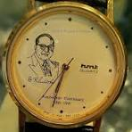

### **📝 What Is It?**

It is a silver wristwatch with a black leather strap. The watch face has Roman numerals, and the brand is "HMT."

### **📜 Its History:**

This watch belonged to my grandfather. He bought it in 1972 when he got his first job as a teacher. He wore it every day to school for over 30 years. After he retired, he kept it safely in a wooden box. When I turned 10, he gifted it to me and told me the story of how proud he was to buy it with his first salary. This watch reminds me of his dedication and love for teaching.

### **🧠 What I Discovered:**

I learned that HMT watches were made in India and were very popular many years ago. They are now considered vintage and special by many collectors.

Model

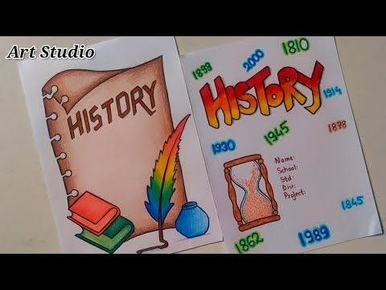

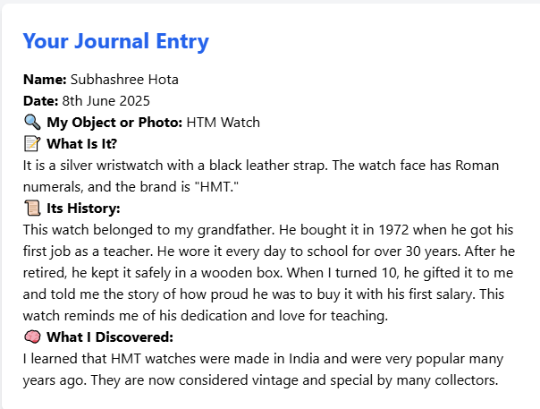

GK CORNER

**Q:** What do we call scientists who study ancient objects and ruins to learn about the past?  
 **A:** Archaeologists  
**Q:** Which ancient tool did early humans use to hunt animals and protect themselves?  
 **A:** Stone tools (like hand axes or spears)

**Q:** What is the name of the period before writing was invented?  
 **A:** Prehistoric period

**Q:** Which famous ancient site in the UK is made of huge standing stones arranged in a circle?  
 **A:** Stonehenge

**Q:** What do we call old written records or objects made by humans, such as pottery or coins?  
 **A:** Artifacts

